**Sprint 1 - Endurance Design Document**

**Table of Contents**

1. **Executive Summary** 
   1. Project Overview
   2. Purpose and Scope of this Specification
2. **Product/Service Description** 
   1. Product Context
   2. User Characteristics
   3. Assumptions
   4. Constraints
   5. Dependencies
3. **Requirements 4**
   1. Functional Requirements
   2. Security
      1. *Protection*
      2. *Authorization and Authentication*
   3. Portability
4. **Requirements Confirmation/Stakeholder sign-off**
5. **System Design** 
   1. Algorithm
   2. System Flow
   3. Software
   4. Hardware
   5. Test Plan
   6. Task List/Gantt Chart
   7. Staffing Plan

1. Executive Summary

1. ***Project Overview***

The objective of this project is to complete the intended Robot project with clear indications on sprints, accuracy and agility. The intended audience for this project is for CS104.

* 1. ***Purpose and Scope of this Specification***

The purpose of this specification is to allow people to use the robot where it is intended to be like on smooth surfaces. The audience for our product could be anything from children to adults, students and professors.

**In scope**

* The product is only meant to smooth surfaces

**Out of Scope**

* The product is not meant to be on uneven or loose surfaces such as carpets and sand

1. Product/Service Description
2. ***Product Context***

The product relates to the other two spirits like the agility test and accuracy test . The product is not independent or self-contained because it needs to be programmed/coded and it needs to be tested. The product is completely useless on its own unless it is controlled by an outside source or another device. Yes the product does interact with a variety of systems. The systems include interacting with the Sphero app for coding and connecting to the app via bluetooth to control the robot.

1. ***User Characteristics***

* Student
* Classmates
* Professor
* Professionals
  1. ***Assumptions***

The availability of the Robot, We also assume that each user is competent in the field of software engineering, and there is also an assumption that syphero would be the operating system that an individual uses in order to make sure that robot meets the desired requirements for this project. In addition, the robot should work as intended, and there is an assumption that each group understands the necessary software to complete the robotics project. Finally, we as a group assumed that the physical conditions of Robot would be less taxing on the project. For example, for this portion of the project endurance, Ryan had tested the robot in his garage. The garage was a smaller room than the room at Monmouth and the wear and tear of his garage included cracks and breaks in the floor.

* 1. ***Constraints***
* Syphero having an update that interferes with how the robot operates
* Measurement requirements may change
* Syphero requires the app be downloaded
* Physical locations the design needs to abide by may change
* One Member had access to the Robot
* Our group works part time/full time jobs
* Covid-19 Limited our opportunities to meet up with fellow group members
* The surfaces that the robot was tested was not smooth surface (it was in a cracked on concrete)
  1. ***Dependencies***
* Robot must follow the correct path or it will not succeed towards the intended path/goal
* Code must be established before project may begin
* The project is dependent on the robot following the correct course

1. Requirements

The requirements involved in the endurance portion had been given to us through professor Eckert outlined in the software development project. The requirements were that our robot had to successfully circumnavigate the course, all. Robot will start from the yellow square with blue tape. Robot then should start with a green light and speak ‘ready set go and stop with a red light and speak ‘I’m done and I need water’. Robot must travel to each of the yellow floor tiles and turn right at the center of each tile. Robot must return to it’s starting location and the robot should not collide with any objects as it goes around the room.In order to implement said requirements we had to fully understand the task at hand. Upon figuring out the exact specifications needed in order to accomplish said requirements we had implemented the via Sphero edu. Once the block code had been written our next job was to scale our project to the size of our workspace and adjust the block code accordingly.

**Priority Definitions**

* Priority 1 – The robot will not collide with any objects in the room
* Priority 2 – The robot must begin at the designated location and nowhere else
* Priority 3- The robot will start as the color green when it begins its pathing
* Priority 4- The robot will ready set go when it is time to start
* Priority 5- Robot must travel to the center of each required tile and then turn right
* Priority 6- Robot must return to its starting position
* Priority 7- Upon reaching desired end point the robot must turn red and say “Im done and I need water”

1. ***Functional Requirements***

|  |  |  |  |  |  |
| --- | --- | --- | --- | --- | --- |
| **Req#** | **Requirement** | **Comments** | **Priority** | **Date Rvwd** | **SME Reviewed / Approved** |
| ENDUR_01 | Robot starts in yellow square | Yellow square= Duct tape | low | 11/11 | R/A  R/A  R/A |
| ENDUR_02 | Robot starts with green light |  | low | 11/11 | R/A  R/A  R/A |
| ENDUR_03 | Robot speaks “ready set go” |  | low | 11/11 | R/A  R/A  R/A |
| ENDUR_04 | Robot travels to each yellow floor tile | Travels to the center of each block | High | 11/11 | R/A  R/A  R/A |
| ENDUR_05 | Robot turns right in middle of yellow tile |  | High | 11/11 | R/A  R/A  R/A |
| ENDUR_06 | Robot must navigate perimeter of given area without hitting any obstacles |  | High | 11/11 | R/A  R/A  R/A |
| ENDUR_07 | Robot returns to starting block | Finishes in the center of the block | High | 11/11 | R/A  R/A  R/A |
| ENDUR_08 | Robot stops with red light |  | low | 11/11 | R/A  R/A  R/A |
| ENDUR_09 | Robot speaks “I’m done and I need water” |  | low | 11/11 | R/A  R/A  R/A |

* 1. ***Security***
     1. **Protection**
* Collaboration on github
* Logging in and out of sphero
* Quality assurance tests
  1. **Authorization and Authentication**

This would be only allowing one member to access the robot. The single member with access to the robot will be able to input code needed for the navigation of the obstacle course. You can have access to the product via a username and password upon use.

* 1. ***Portability***

If portability is a requirement, specify attributes of the system that relate to the ease of porting the system to other host machines and/or operating systems. For example,

* Percentage of components with host-dependent code;
* Percentage of code that is host dependent;
* Use of a proven portable language;
* Use of a particular compiler or language subset;
* Use of a particular operating system;
* The need for environment-independence - the product must operate the same regardless of operating systems, networks, development or production environments.

1. Requirements Confirmation/Stakeholder sign-off

|  |  |  |
| --- | --- | --- |
| **Meeting Date** | **Attendees (name and role)** | **Comments** |
| 11/09/20 | Ryan (Tester) | R/A |
| 11/09/20 | Evan (Organizer/Design/Scribe) | R/A |
| 11/09/20 | Daniel (Coder/Scribe) | R/A |

1. System Design
2. ***Algorithm***
3. Robot will start from the yellow square within the blue tape
4. Upon beginning robots color will turn green
5. After robot turns green it will speak ready ster go and begin
6. Robot will move upwards at 0 degrees
7. Then Robot will move right at 90 degrees
8. Then will roll at 180 degrees
9. Then will move left at 270 towards
10. Finishes at the starting position
11. Upon reaching starting position robot will turn red
12. Upon finish robot will say “im done and I need water”
    1. ***System Flow***

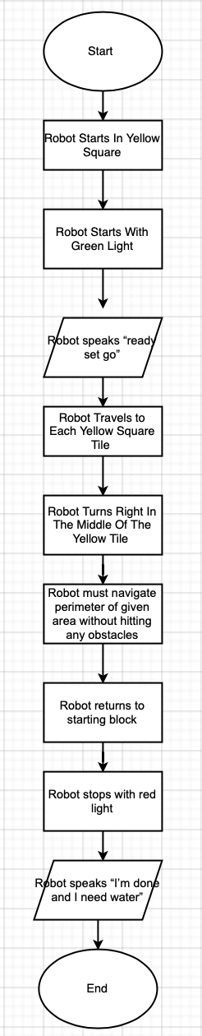

* 1. ***Software***

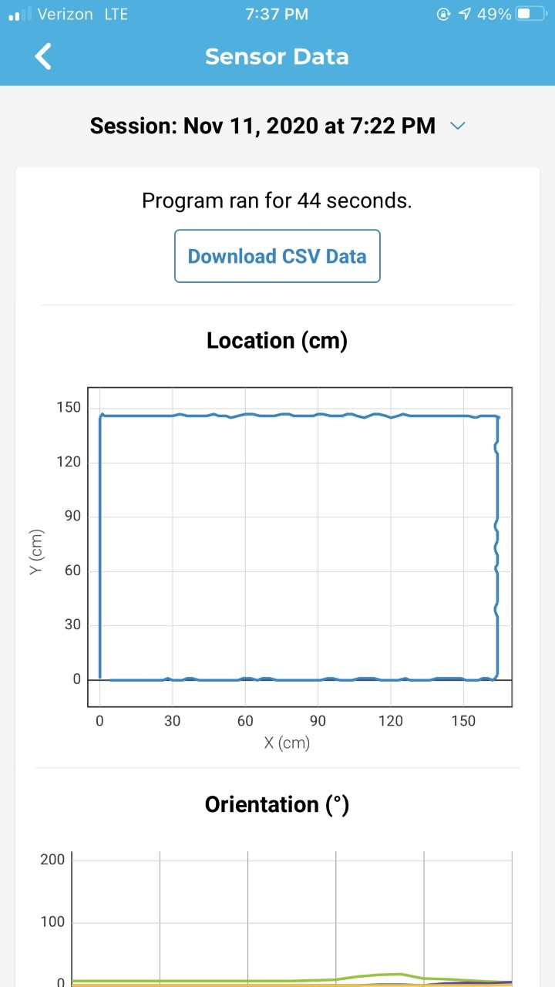

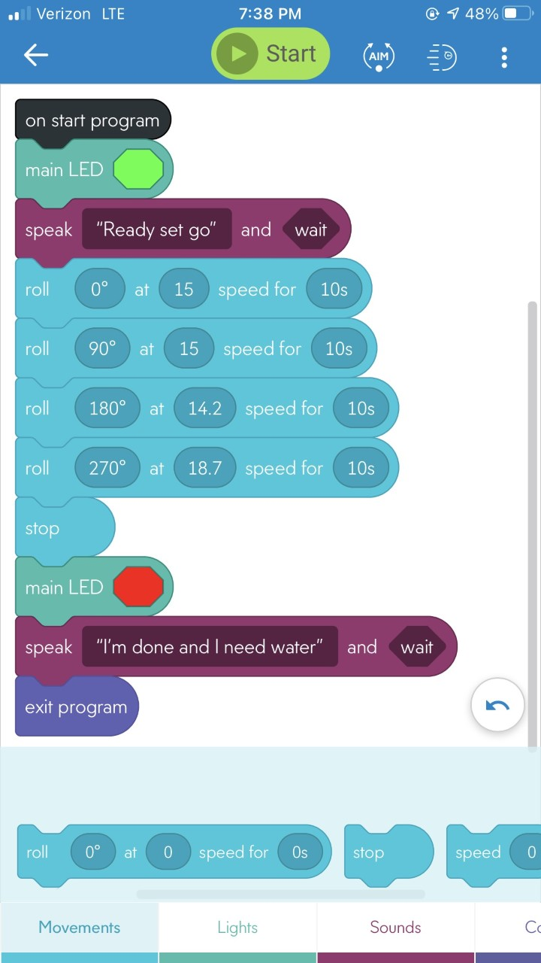

The software platform used to establish our code was sphero, We used block code and other other various types of code within the sphero interface in order to make the robot respond to our requirements

* 1. ***Hardware***

Describe hardware platforms that were used to develop, test and demonstrate this application

The hardware which has been used in the production of this project include github and syphero

1. ***Test Plan***

Include a test plan showing all unit tests performed for this application, Include test rational, test date, staff member, pass/fail status

|  |  |  |  |  |  |
| --- | --- | --- | --- | --- | --- |
| **Reason for Test Case** | **Test Date** | **Expected Output** | **Observed Output** | **Staff Name** | **Pass/Fail** |
| Green light at start | 11/10 | Lights up green | Lit up green | Ryan | Pass |
| Speaks “Ready set go” at start | 11/10 | Speaks “ready set go” | Speaks “Ready set go” at start | Ryan | Pass |
| Red light at finish | 11/10 | Lights up red | Lit up red | Ryan | Pass |
| Speaks “I’m done and I need water” at finish | 11/10 | Speaks “I’m done and I need water” at finish | Spoke “I’m done and I need water” at finish | Ryan | Pass |
| Turns at middle of boxes | 11/10 | Turns at middle of boxes | Did not turn at middle | Ryan | Fail |
| Turns at middle of boxes | 11/10 | Turns at middle of boxes | Did not turn at middle | Ryan | Fail |
| Turns at middle of boxes | 11/10 | Turns at middle of boxes | Did not turn at middle | Ryan | Fail |
| Turns at middle of boxes | 11/11 | Turns at middle of boxes | Did not turn at middle | Ryan | Fail |
| Turns at middle of boxes | 11/11 | Turns at middle of boxes | Turns at middle of boxes | Ryan | Pass |

* 1. ***Task List/Gantt Chart***

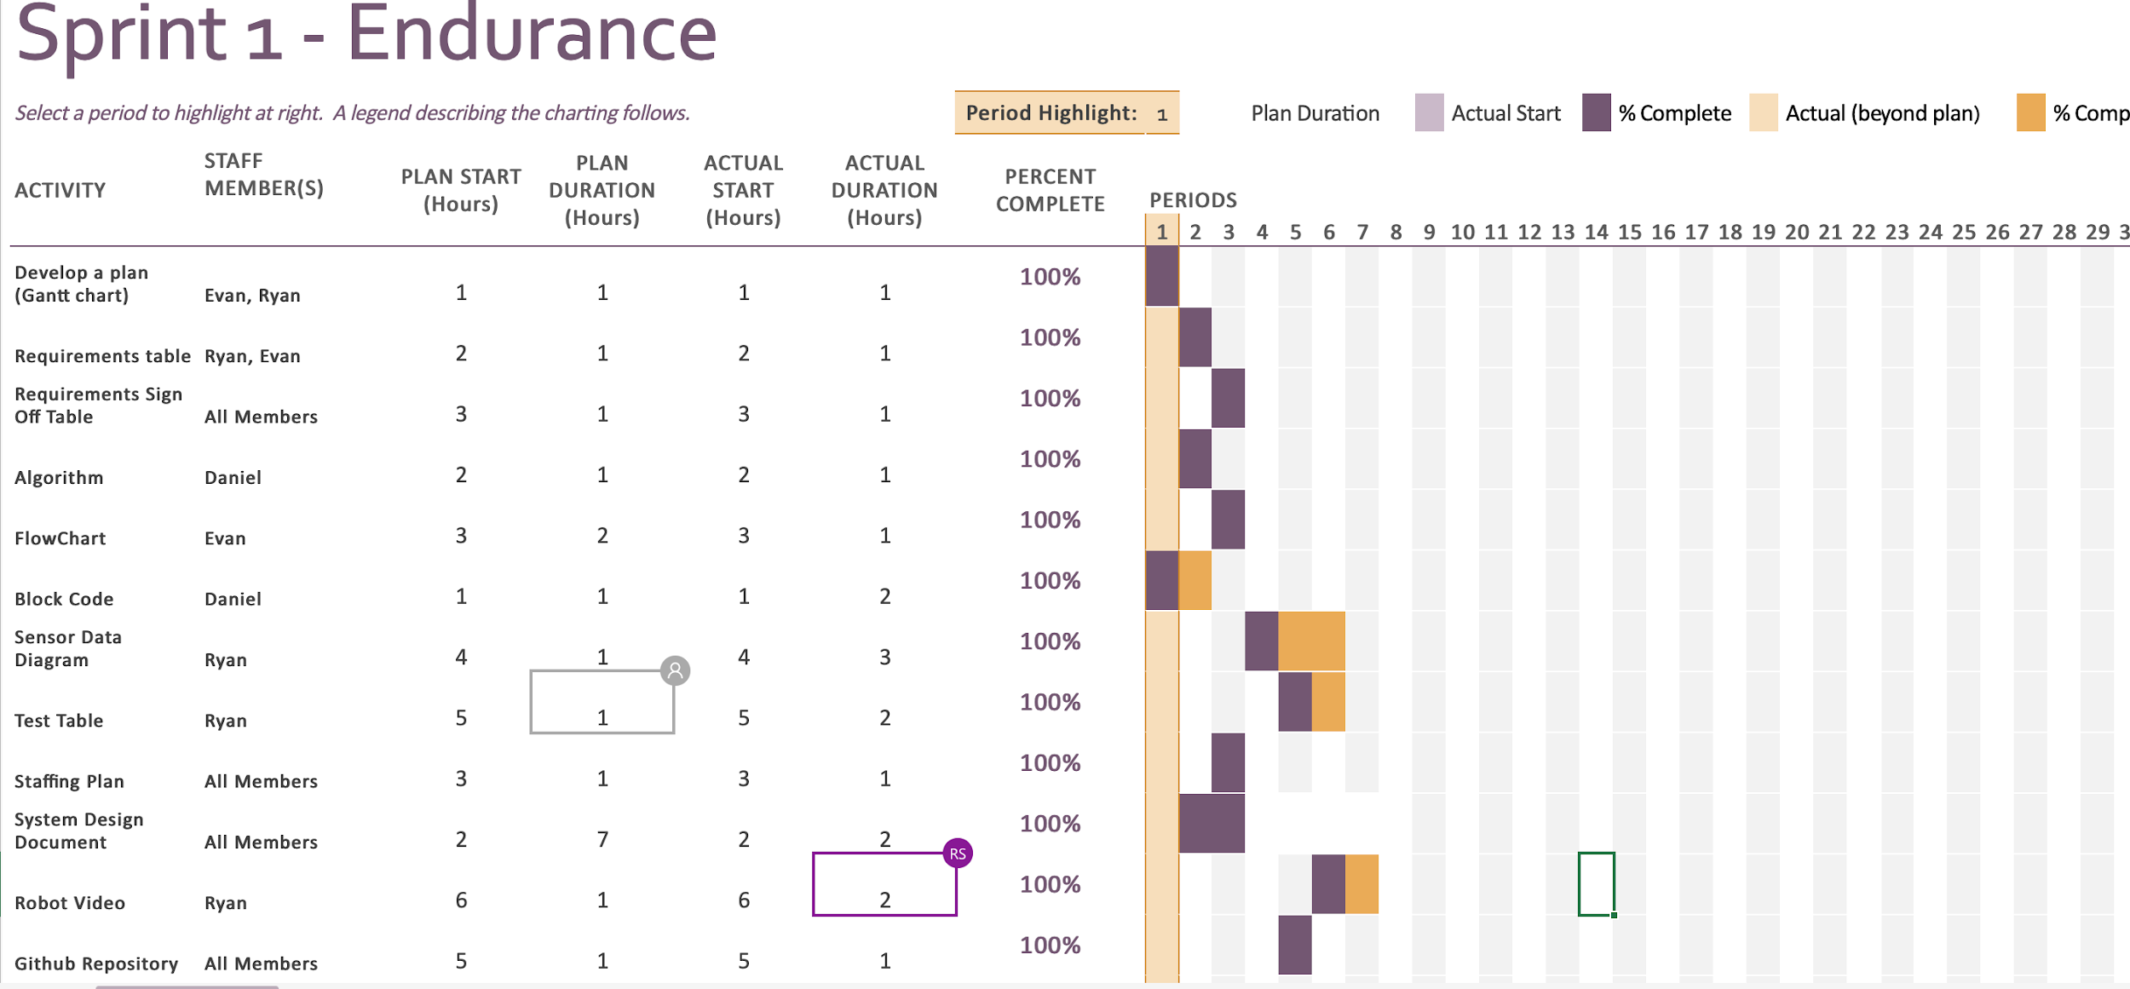

* 1. ***Staffing Plan***

|  |  |  |  |
| --- | --- | --- | --- |
| Name | Role | Responsibility | Reports To |
| Daniel | Group member | Coder/Scribe | N/A |
| Ryan | Handler of the Robot (testing) | Testing | N/A |
| Evan | Group member | Organizer/Design/Scribe | N/A |